HTTP is a request and response protocol based on the client/server architecture.

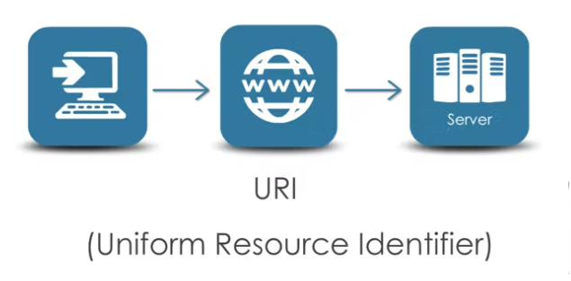The browser sends a request to the server, so how does the request know where to go? The name and location of the server is provided by an URI, or Uniform Resource Identifier.

URI's are formatted strings that contain the name, location, and any other related information to identity a resource, in our case an HTTP service. The URI serves as the address of a HTTP resource.

Also with the request, HTTP allows certain Request Methods or Verbs which describes what you want to do with the resource.

There are 4 key verbs that Web API uses, and they are GET, POST, PUT, and DELETE.

**GET**: used to retrieve information from the server.

**POST**: used to add a record or add data to the server.

**PUT**: used to edit data that is currently on the server with the data being sent, from Lets say an Edit page.

**DELETE**: deletes data from the server.

Knowing what each of these HTTP verbs are used for is very important with Web API, so if this is the first time hearing these verbs, write them down and memorize them.

Other than the URI and the type of HTTP Request you are sending, you can also add *Request Headers* to send with the request. Request Headers allow you to send other data along with the request that is needed by the server.

With any HTTP request, the client needs to specify what type of data they are expecting with the response. This is done with the *Accept Header.*

If you want to send data with the request such as values from a form, you need to specify the *Content-type header* with the request so the server knows what type of data to expect.

The data you want to send with the request is contained in the *Request Body*.